**Callaloo Soup**

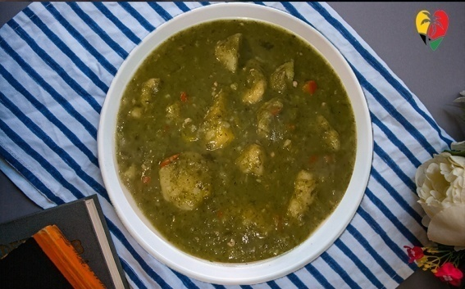

**INGREDIENTS**

2 bundles callaloo

12 ozs Beef salted meat

1 lb tannia

12 cups water

1 tsp garlic

½ cup chopped onion

1 tbsp salt

½ cup chive

½ tsp all-purpose seasoning

¼ tsp pepper

2 potatoes

2 cups coconut milk

**INSTRUCTIONS**

Cut up salt meat and soak for 3/4 to 1 hour if using.

1. Cook for 1/2 hours with fresh meat.
2. Wash dasheen leaves thoroughly before chopping them up and adding them to the meat.
3. Bring the water to a boil. If you're using blended callaloo, be sure to add the meat before bringing it to a boil.
4. Add the other ingredients and season to taste.
5. Cook until the vegetables are tender.
6. Ten minutes before turning off the heat, add the dumplings

NOTES

Soak dry grated coconut in boiling water to make coconut milk. Allow cooling before serving. Strain the milk through a fine strainer and squeeze it out.